**PRACTICAL 1**

**AIM:-** Use Google & Whois for Reconnaissance.

**TOOLS:-** Using Who.is

Step 1: Open the Who.is website.

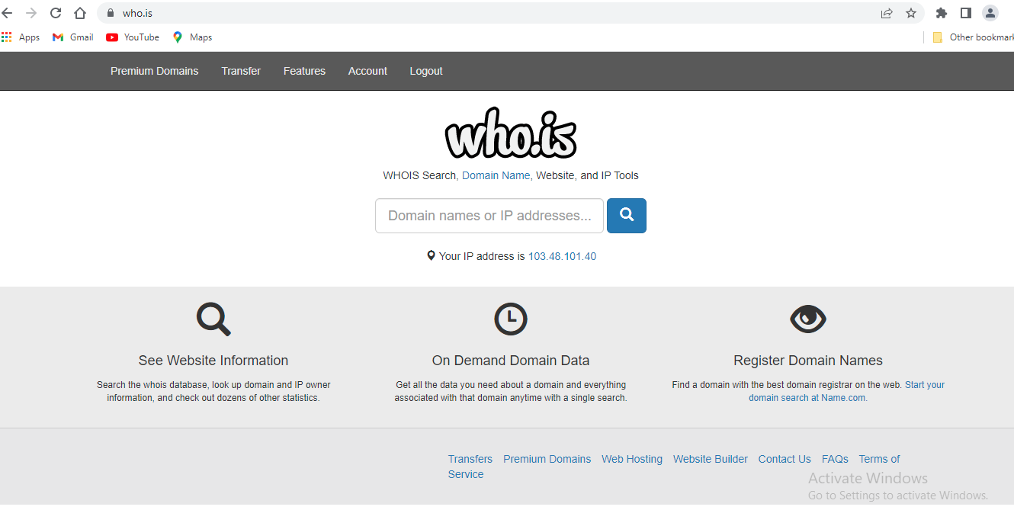

Step2: Enter the website name & hit the “Enter Button”.

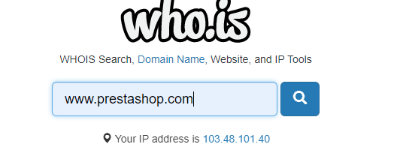

Step3: Show you the information about prestashop.com

